Target Windchill 13.0.2.0 Installation
Schindler CRD Applications

Exported on 2025-08-19 06:22:27

Table of Contents

1 3
2 Prerequisites: 4
3 Installation of Amazon Corretto 17.0.11.9.1: 5
4 SQL Server 2019 Standard DB Installation and Windchill DB User Creation: 8
5 OpenDJ Installation for Windchill 13.0.2.0: 9
6 Windchill 13.0.2.0 Installation: 13
6.1 List of Software's: 13
6.2 Procedure: 13
7 Windchill Launching Issue: 27

- Prerequisites:
- Installation of Amazon Corretto 17.0.11.9.1:
- SQL Server 2019 Standard DB Installation and Windchill DB User Creation:
- OpenDJ Installation for Windchill 13.0.2.0:
- Windchill 13.0.2.0 Installation:
  - List of Software's:
  - Procedure:
- Windchill Launching Issue:

Prerequisites:
- Need Admin access on Windchill Application server.

Installation of Amazon Corretto 17.0.11.9.1:
- Download Amazon Corretto 17.0.11.9.1 using the below link.
Download Link: Release 17.0.11.9.1 · corretto/corretto-17 · GitHub
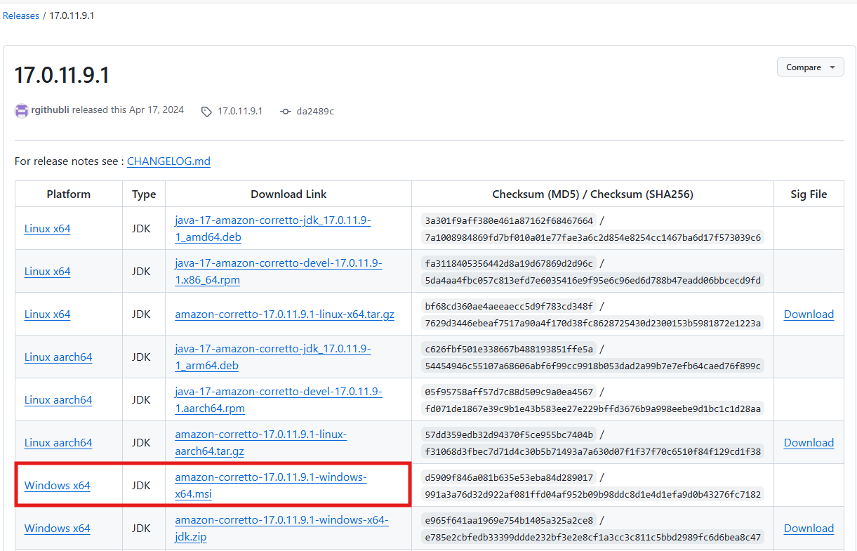

2. Extract the installable, right click and install as shown below.
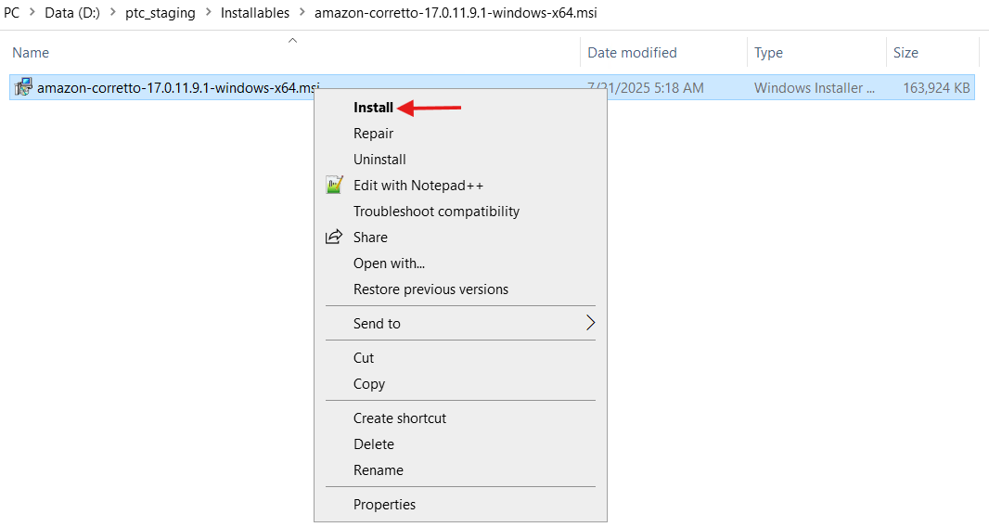

3. Click Next as shown below.
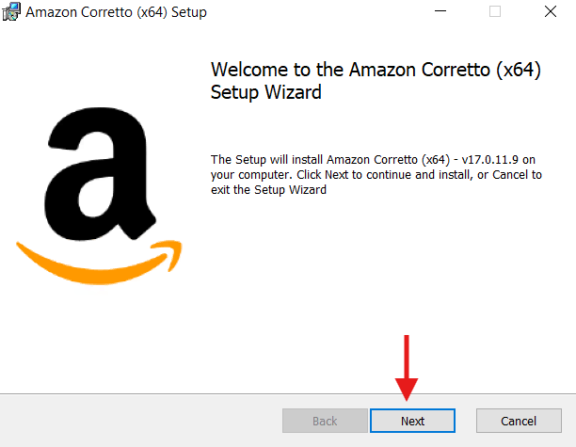

4. Browse the location as shown below and click on Next.
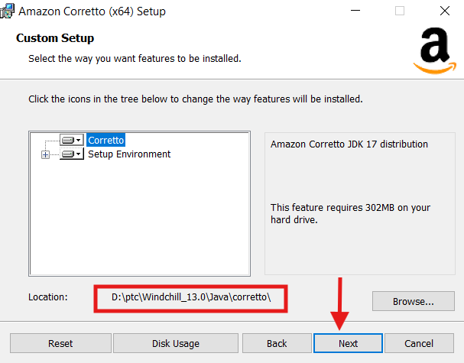

5. Click Install to begin the installation as shown below.
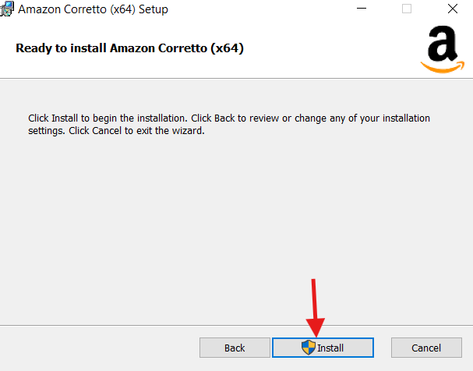

6. Click Finish button to complete the setup as shown below.
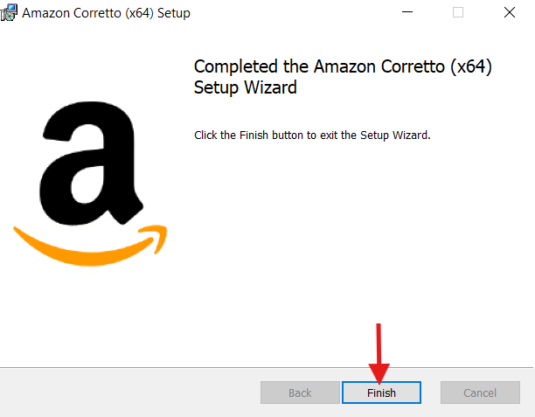

7. Please make sure the following environmental variables are in place after the installation.
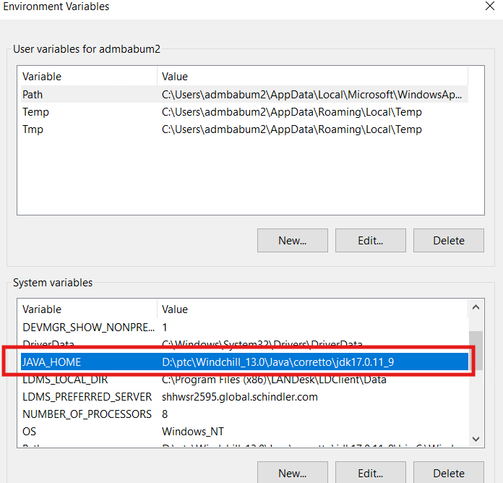

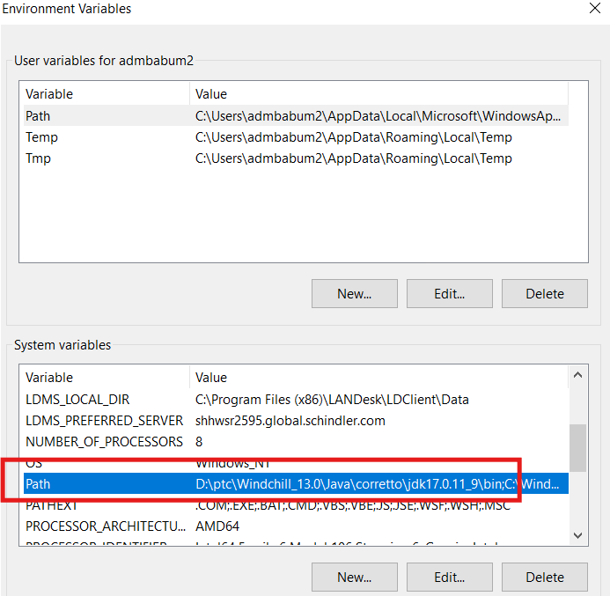

8. Restart the server.

SQL Server 2019 Standard DB Installation and Windchill DB User Creation:

- DB team installed SQL Server 2019 Standard DB on New SQL Server.
- For creating the Windchill DB User, we raised an Incident and connected with DB team to explain them the process suggested in the section "Manually creating SQL Server database for Windchill" by PTC as per below article.
Article - CS28197 - How to Manually Create a SQL Server Database for Windchill PDMLink
3. As the Schindler DB team is having their own best practices to create Windchill DB user with the help of script they simply executed that script to create DB and Windchill DB user.

OpenDJ Installation for Windchill 13.0.2.0:

- Download the installable using the following URL: Releases · OpenIdentityPlatform/OpenDJ
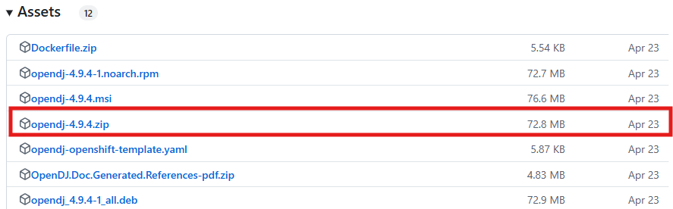
2. Copy the installable onto Target server.
3. Create the below folder structure as shown below.

4. Unzip/Extract the installable and copy all files and folder to the below folder as shown.
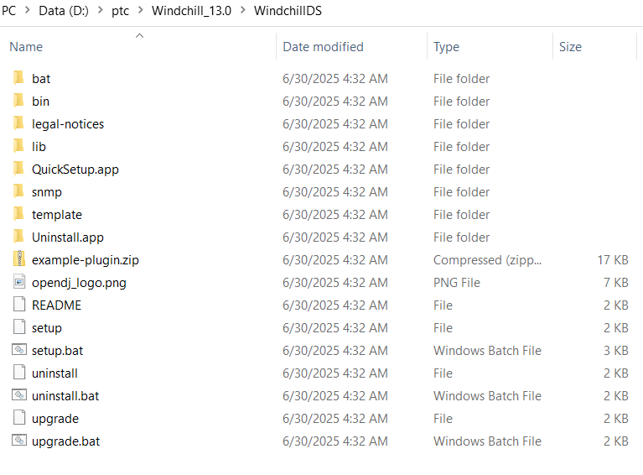

5. As shown below right click and run setup.bat as administrator.
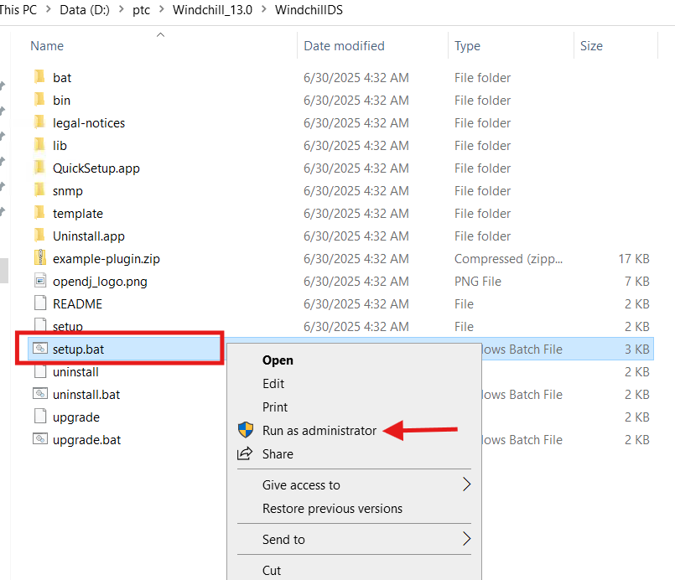

6. Click Next on Welcome page as shown below.
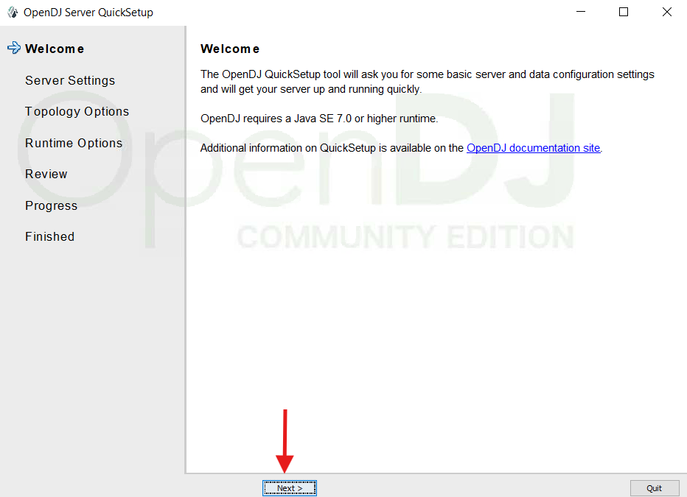

7. Provide the details as shown below and click on Next.
Root User DN: cn=Manager
Password: ldapadmin
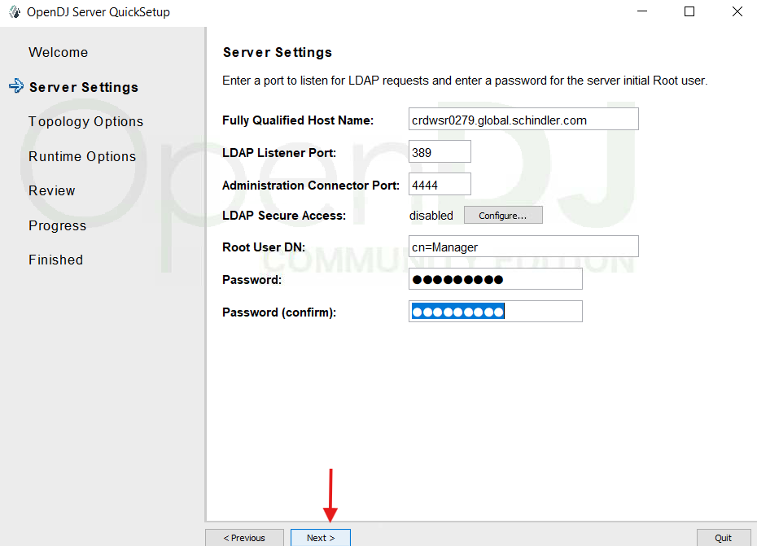

8. Select the following check-box “This will be a standalone server” and Click Next.
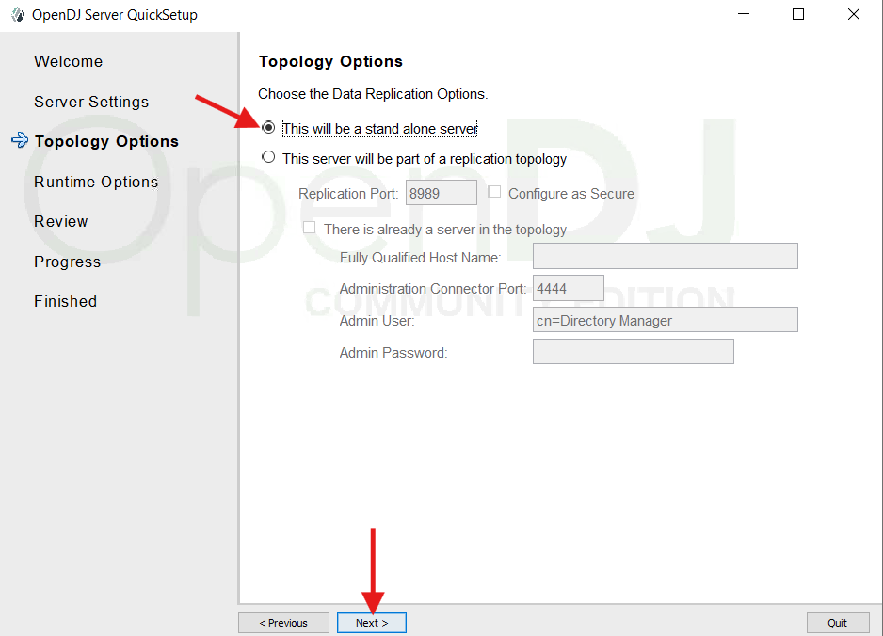

9. Enter Directory Base DN: o=schinder as shown below, select "Only Create Base Entry (o=schindler)" and click on Next.
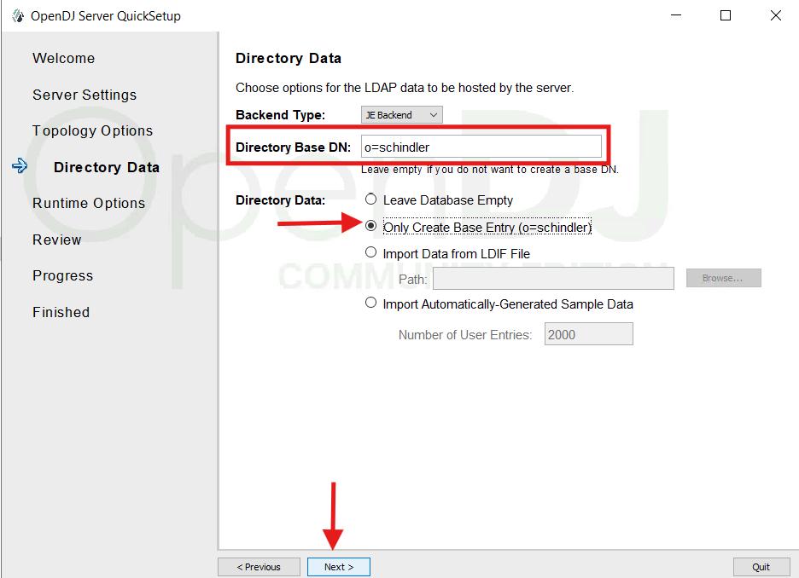

10. Click Next as shown below.
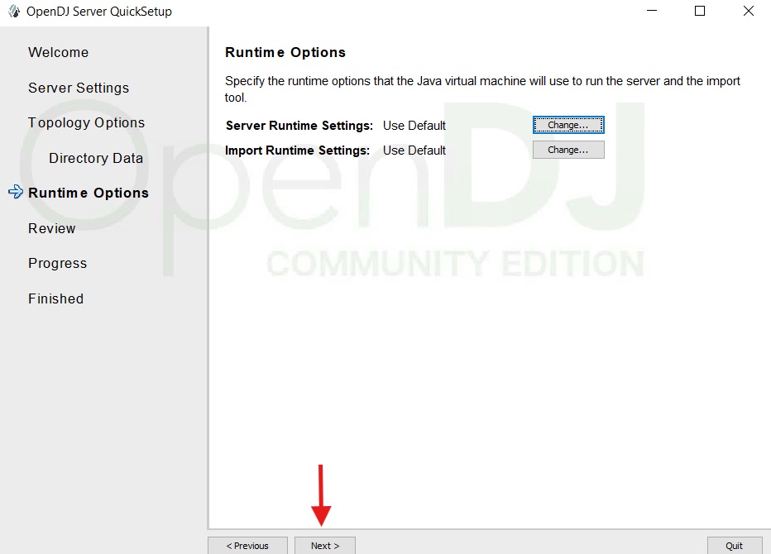

11. Review the settings and Click on Finish.
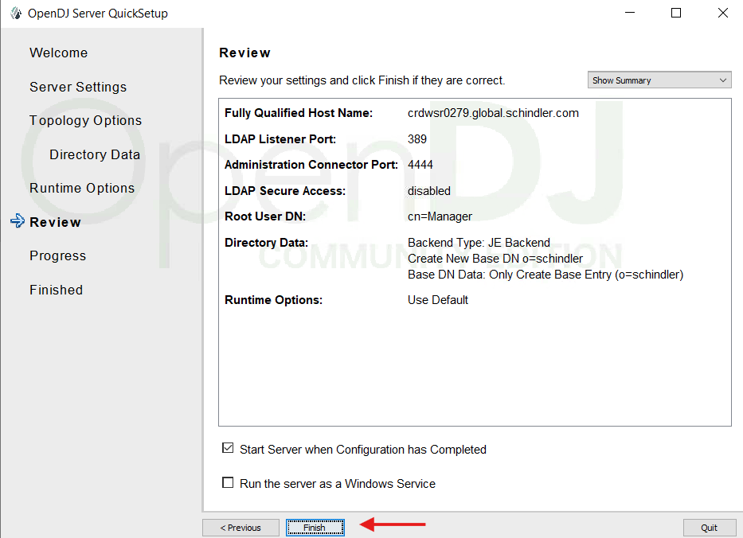

12. Click on Close.
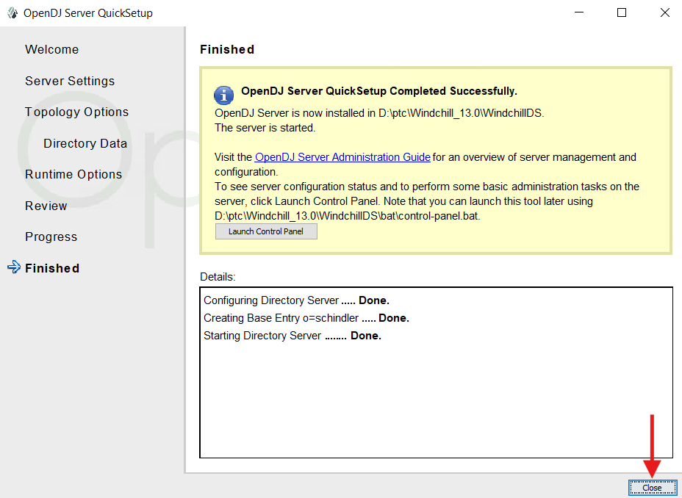

Windchill 13.0.2.0 Installation:

List of Software's:
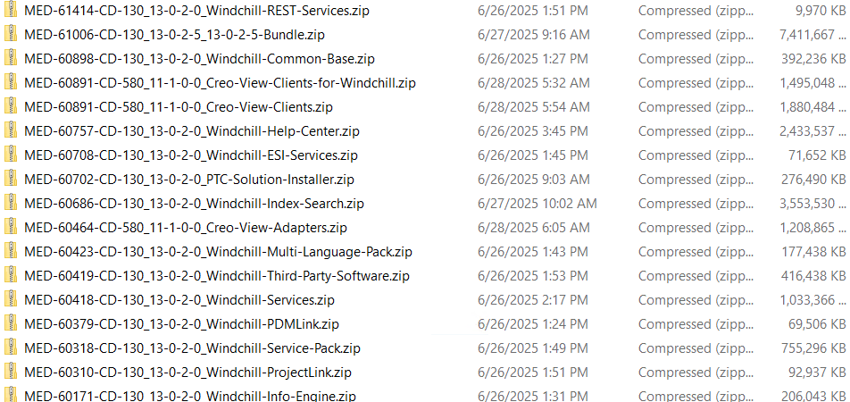

Procedure:
- Please make sure Windchill DS (OpenDJ) is running while installing Windchill.
- Extract all the installables into a folder as shown below.
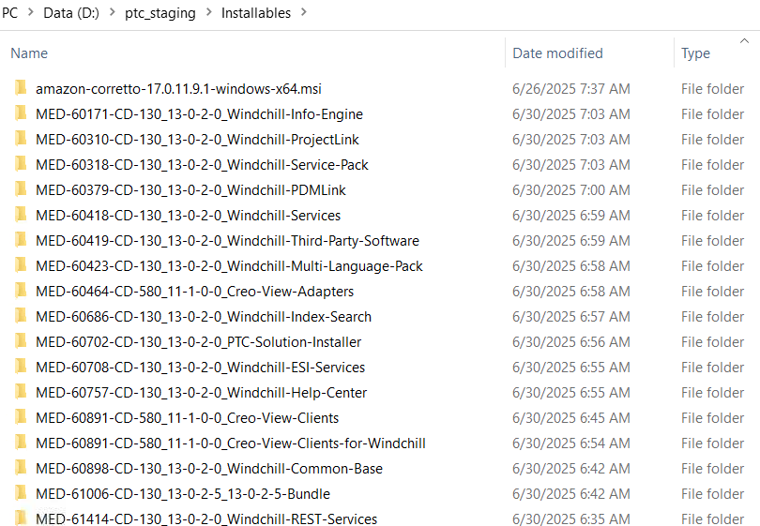

3. Run command prompt as Administrator and stage the directory to PSI installable extracted folder and execute setup.vbs as shown below.
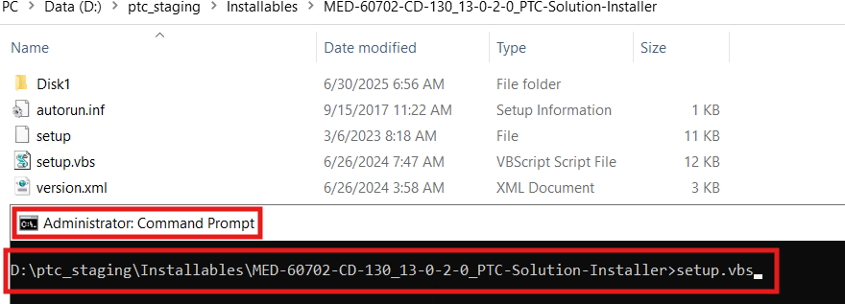

4. Click on Ok as shown below.
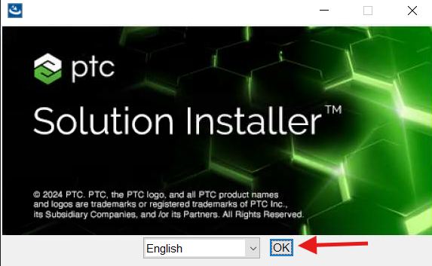

5. Click on Next as shown below.
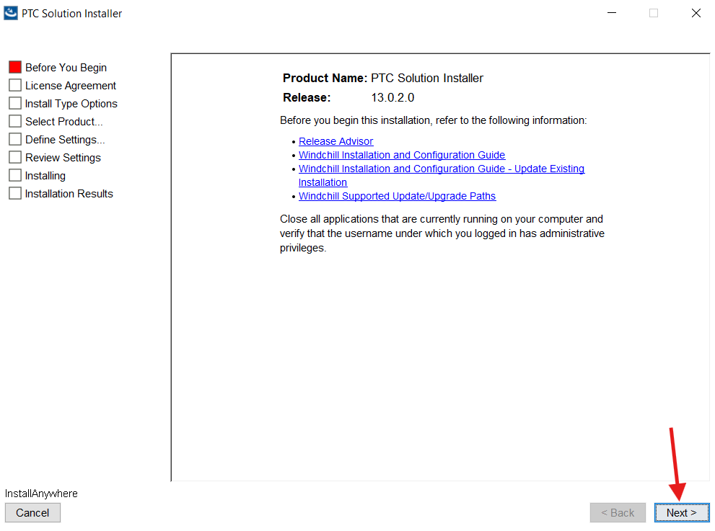

6. Select “I accept” and click on “Next” as shown below.
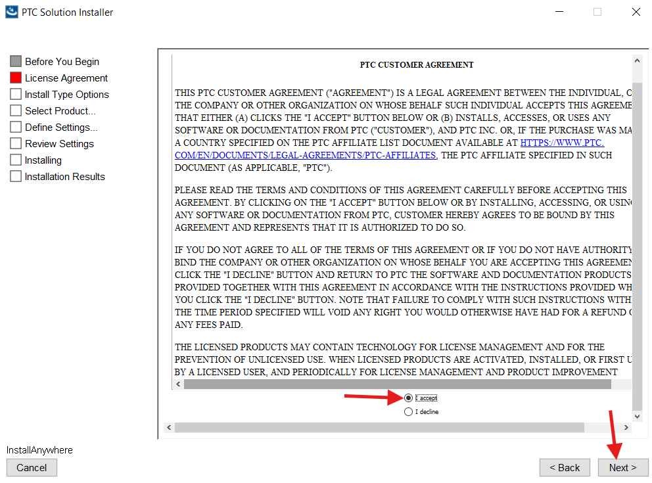

7. Select I have read the above statement and click Next as shown below.
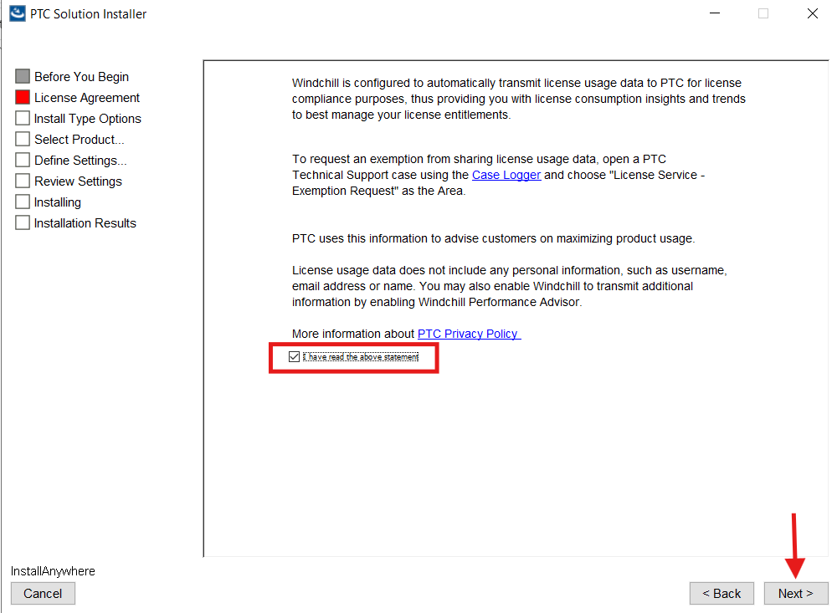

8. Select New Product Installation and click Next as shown below.
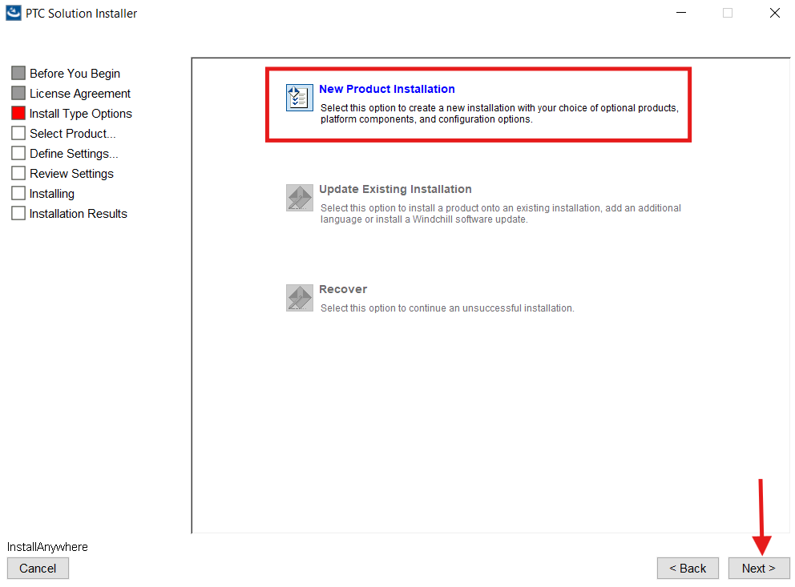

9. Under the Product Life Management select Windchill PDMLink & Windchill ProjectLink and click Next as shown below.
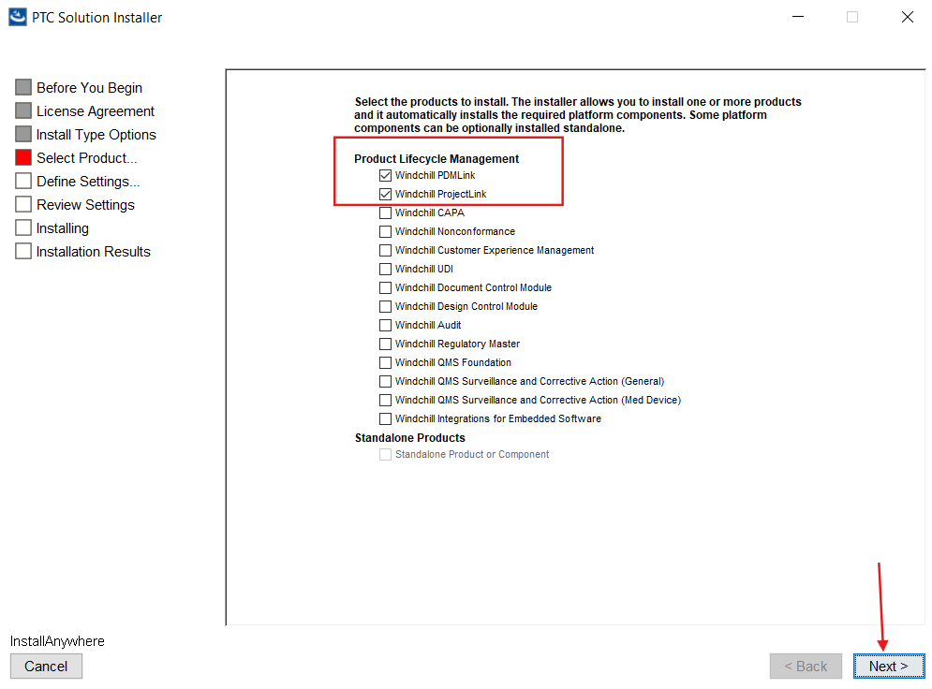

10. Select the components as follows and click on Next:
- Under the Windchill Integration - select Windchill ESI Services.
- Under the Windchill Base Solution Add-ons - select Windchill index Search Client.
- Under the Windchill Visualization - select Creo View.
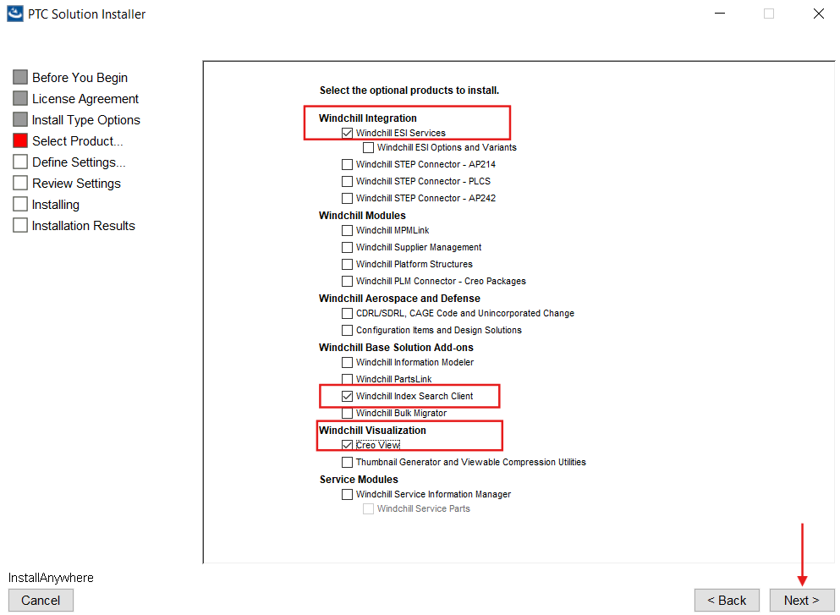

11. Select “SQL Server” and click Next as shown below.
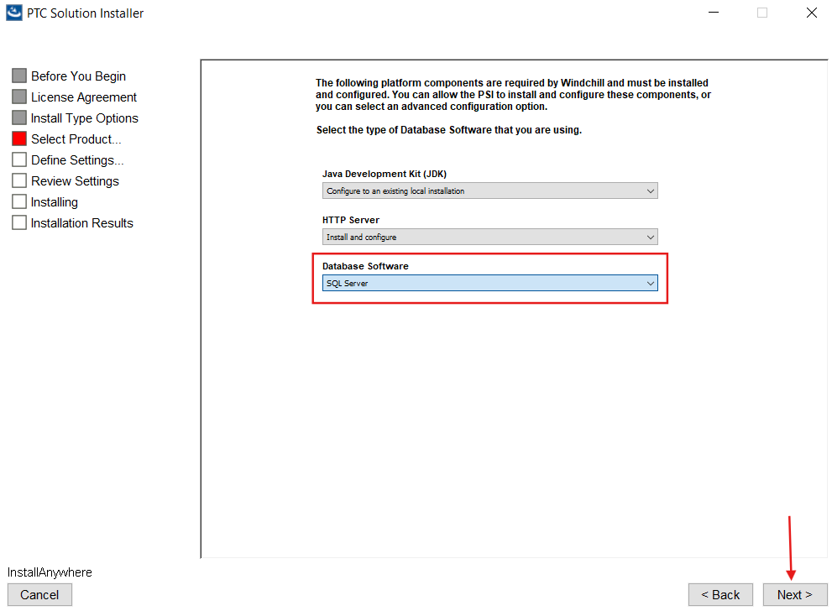

12. Select Enable remote File Server Support and click Next.
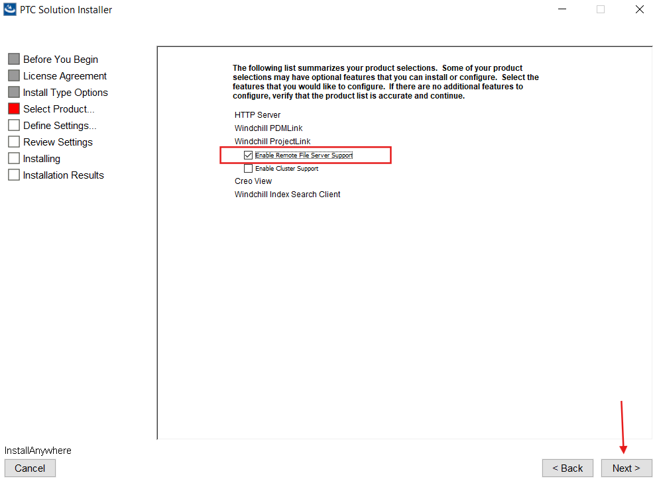

13. Select Configure Windchill PDMLink for use with ERP Connector and click Next as shown below.
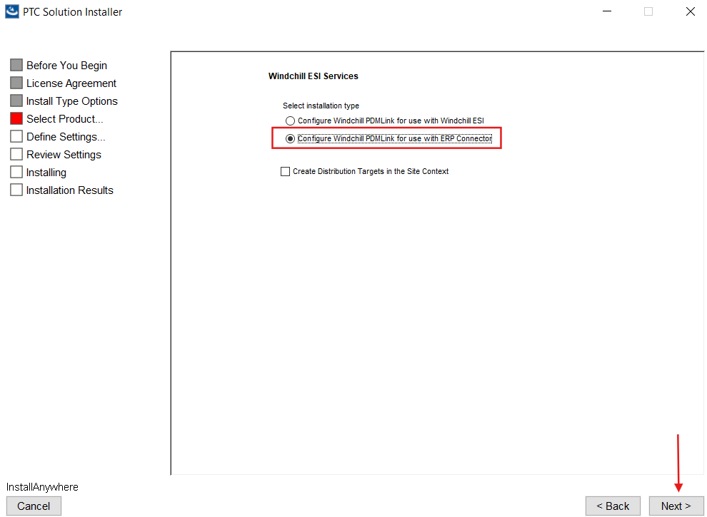

14. Select Use Existing for Database & Database Installation User and click Next as shown below.
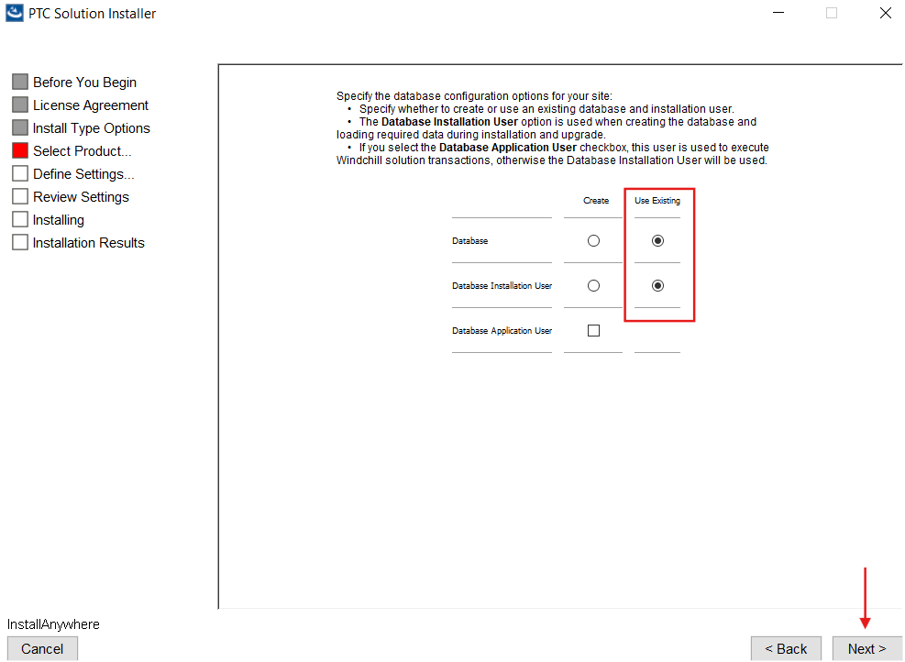

15. Give Installation Name as "WindchillQAInstallation23072025" and Click Next.
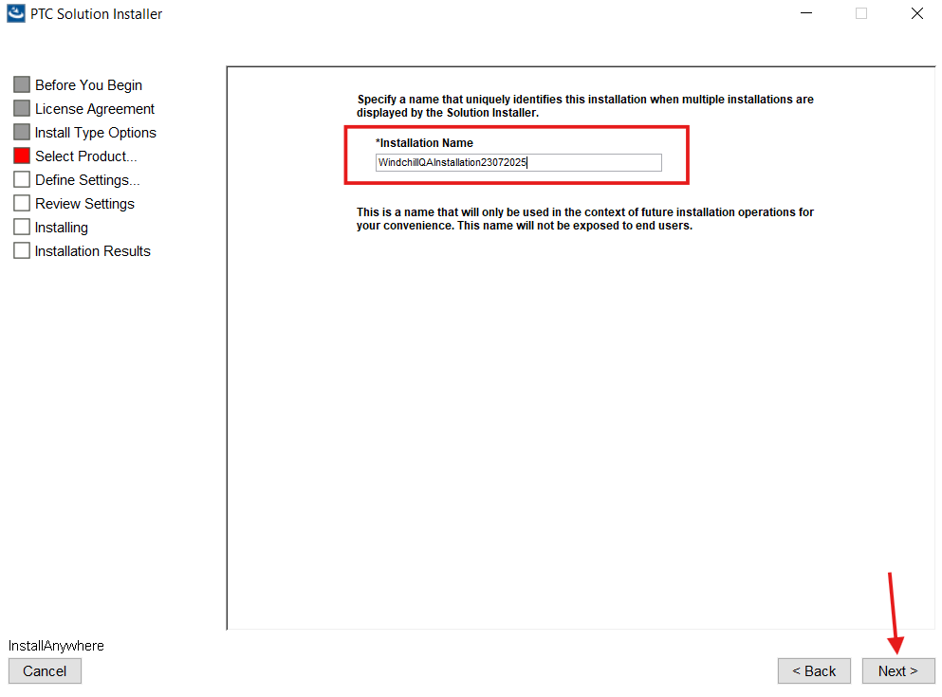

16. Provide Base Installation Directory as “D:\ptc\Windchill_13.0” and Click Next.
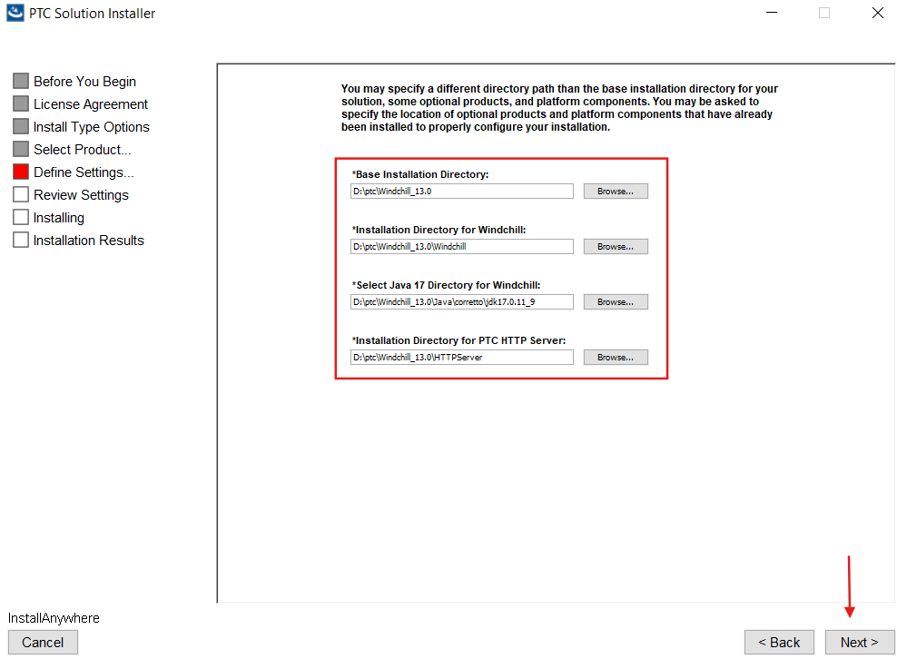

17. Provide the details as follows and click on Next.
- Web Server DNS Registered Host Name as “edm-q.global.schindler.com”
- HTTP Port Number as “80”
- HTTPS Port Number as “443”
- Servlet Engine Web Server Listener Port Number as “8010”
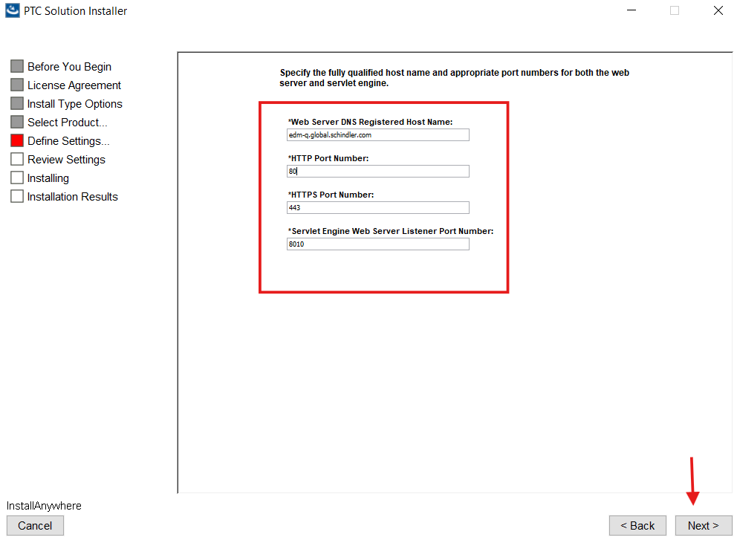

18. Provide the details as follows and click on Next.
- Base Data Language as “English”
- Display Languages as “German”
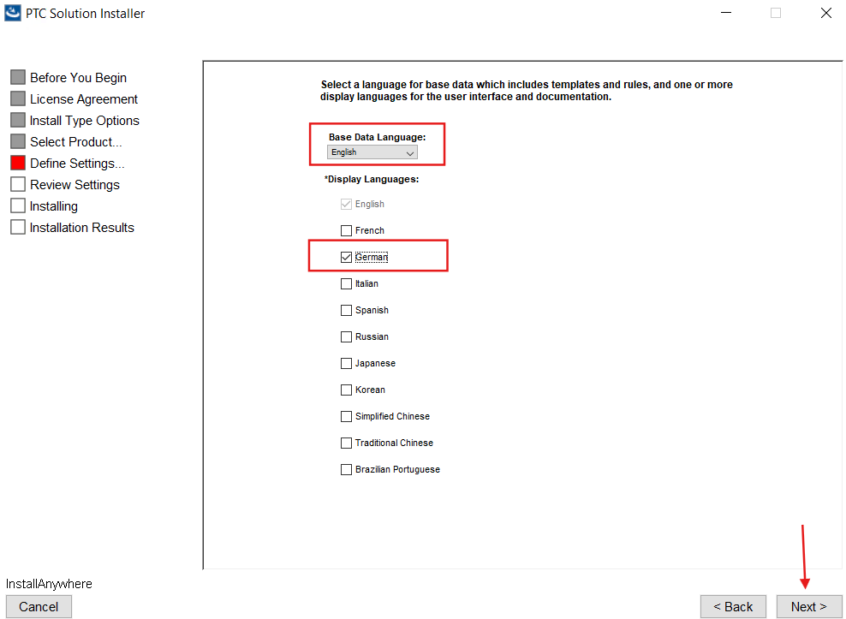

19. Provide the details as follows and click on Next.
- LDAP Adapter Name as ”com.schindler.global.Ldap”
- Base Distinguished Name for LDAP Users as o=schindler
- LDAP Server Host Name as crdwsr0279.global.schindler.com
- LDAP User Distinguished Name as “cn=Manager”
- LDAP Password as “ldapadmin”
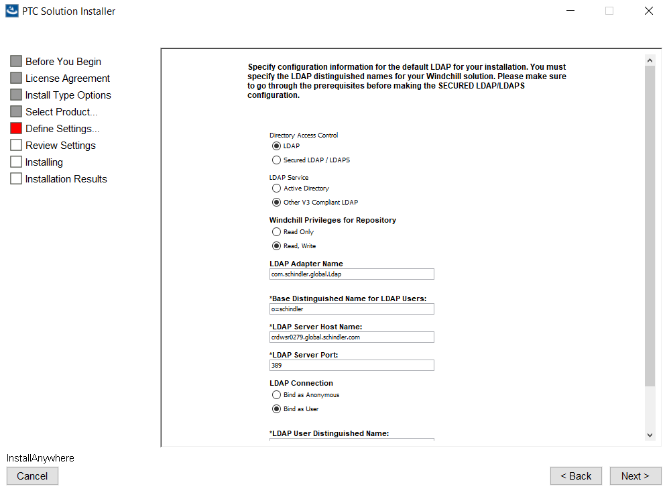
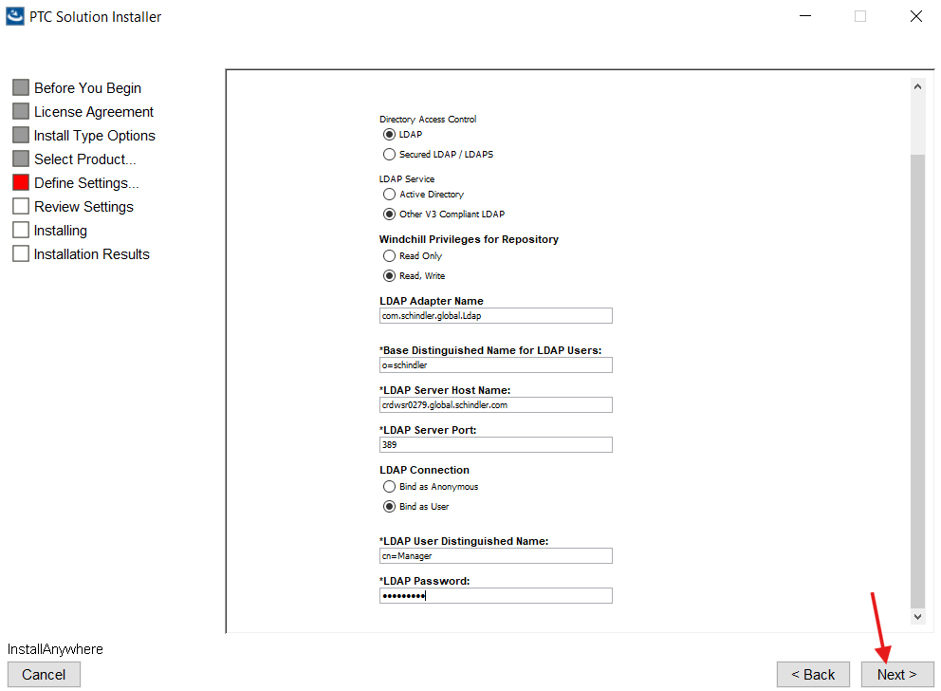

20. Click Next.
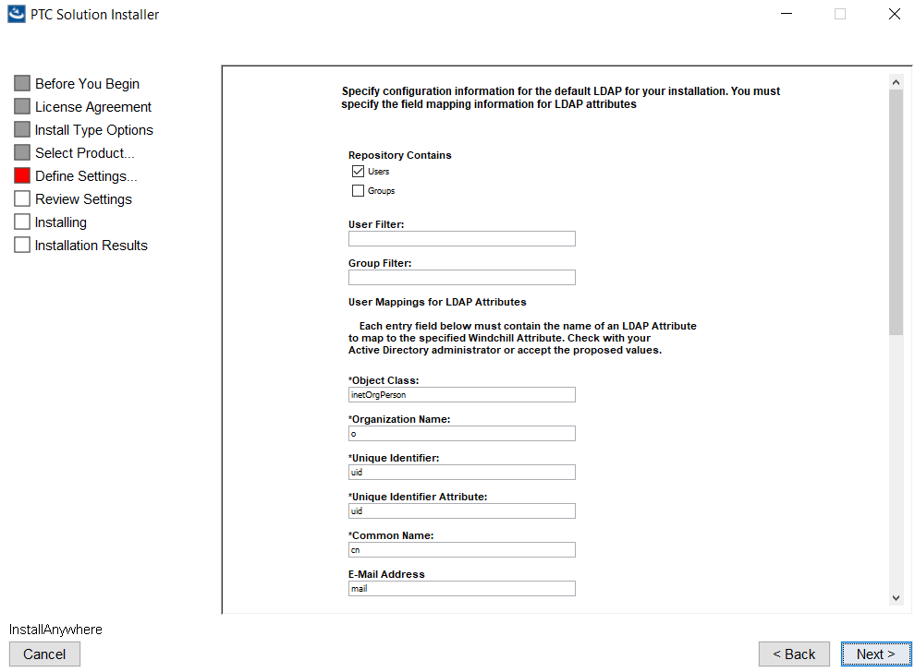
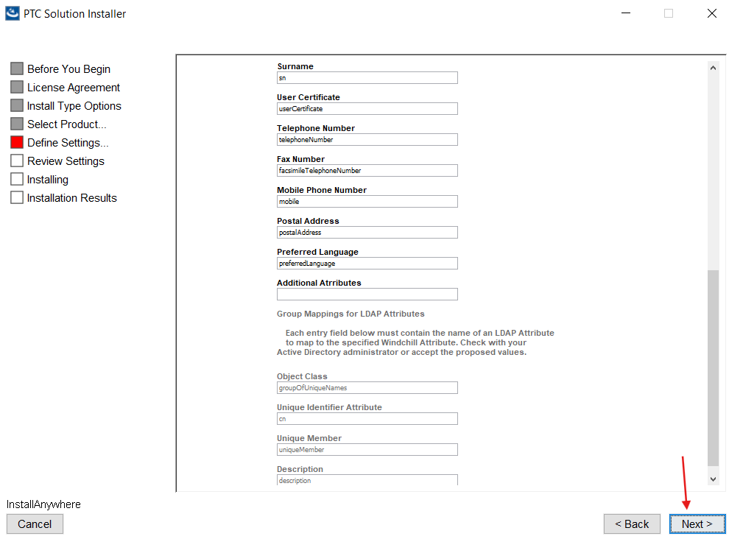

21. Select “Create database schema” and “Load base data” and click Next as shown below.
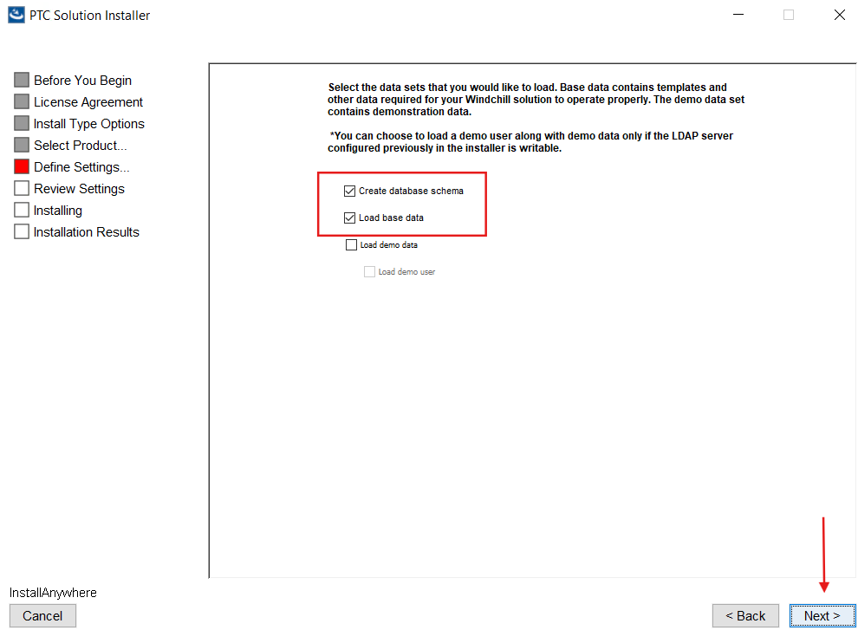

Note: For SQL DB User below is the Password Policy from PTC:
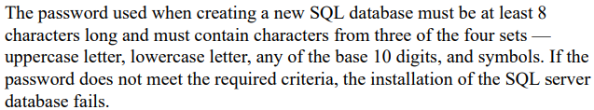

22. Provide the details as follows and click on Next.
- SQL Server DNS Registered Host Name as "shhwsr2923.global.schindler.com"
- TCP Port Number for SQL Server Instance as “1433”
- SQL Server Username for Windchill Installation as “pdmlink”
- SQL Server User Password for Windchill Installation “xxxxxxxxxxxx” (Password of pdmlink user)
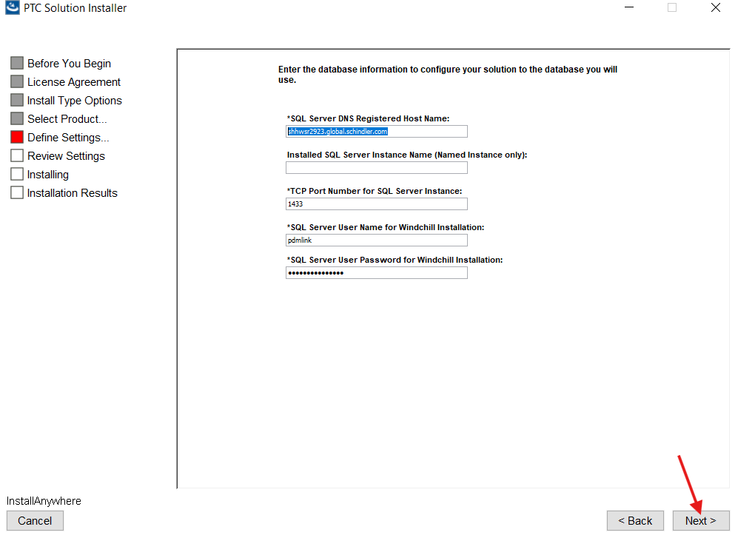

23. Select Configure License Later and click on Next.
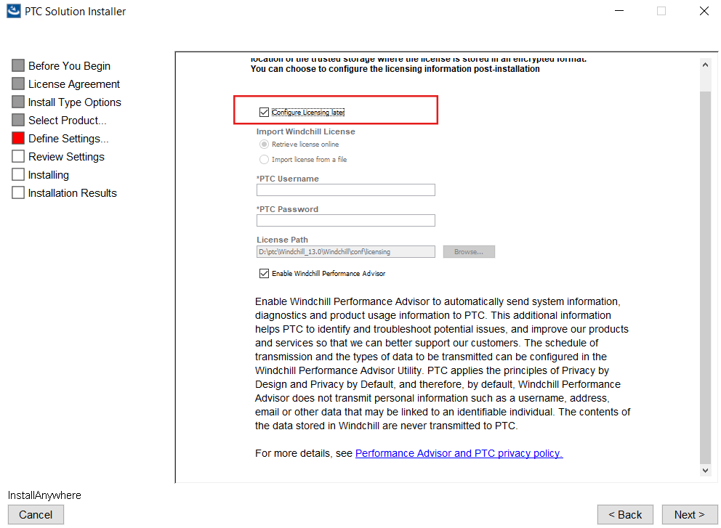

24. Provide the details as shown below and click Next.
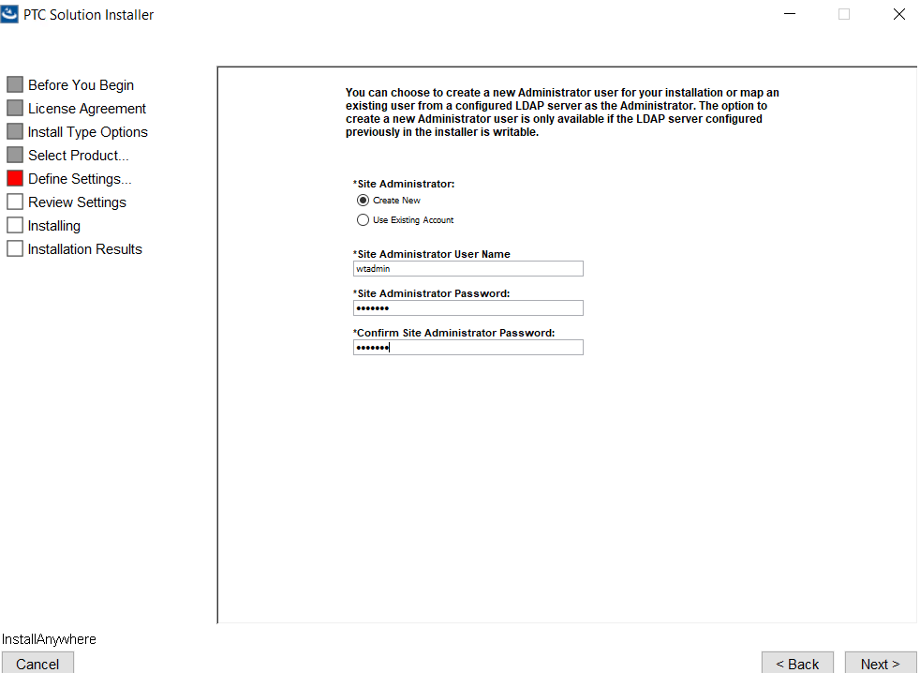

25. Provide the details as follows and click on Next.
- Select “Organization”
- Web Application Context Root as “PDMLink”
- Info*Engine Server Task Processor Port Number as “10002”
- Initial Organization Name as “CRD”
- Organization Internet Domain Name as “schindler.com”

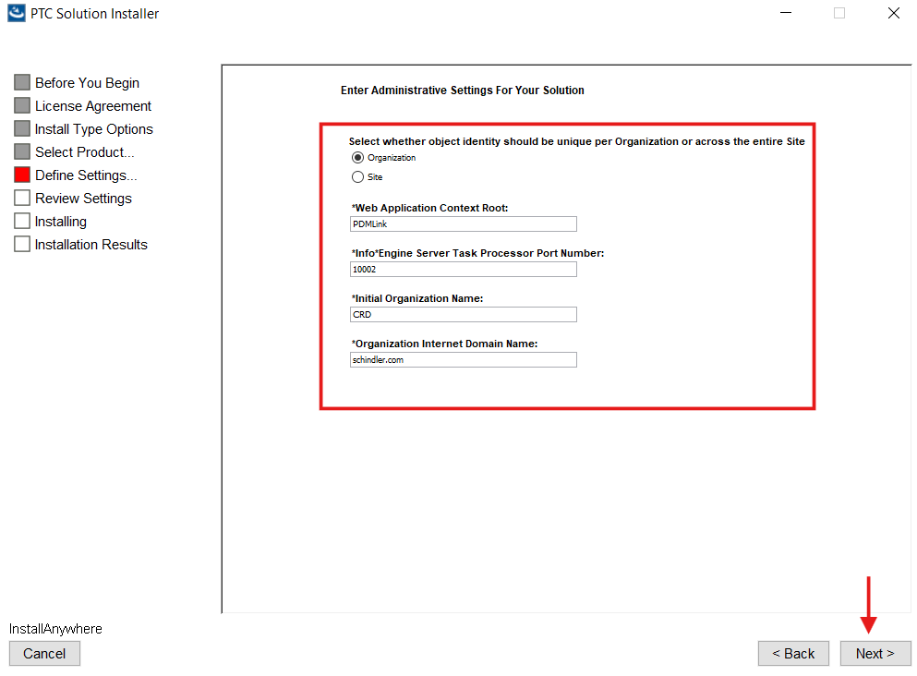

26. Provide the details as shown below and click on Next.
- Check “Enable Windchill Index Search”
- Give Windchill Index Search Host Name as “edm-q.global.schindler.com”
- Windchill Index Search Port Number as “8085”
- Windchill Index Search Administration User and Password
- Select Default Indexing Language as “English”
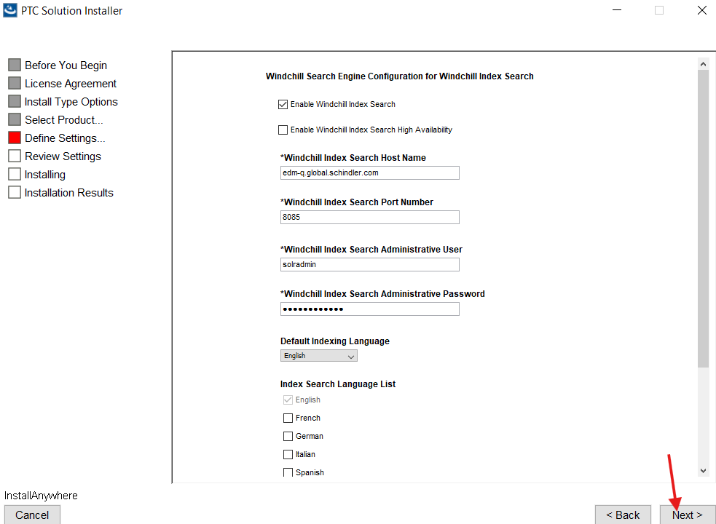

27. Make sure “In a new Program Group Windchill_13.0” is selected and click Next.
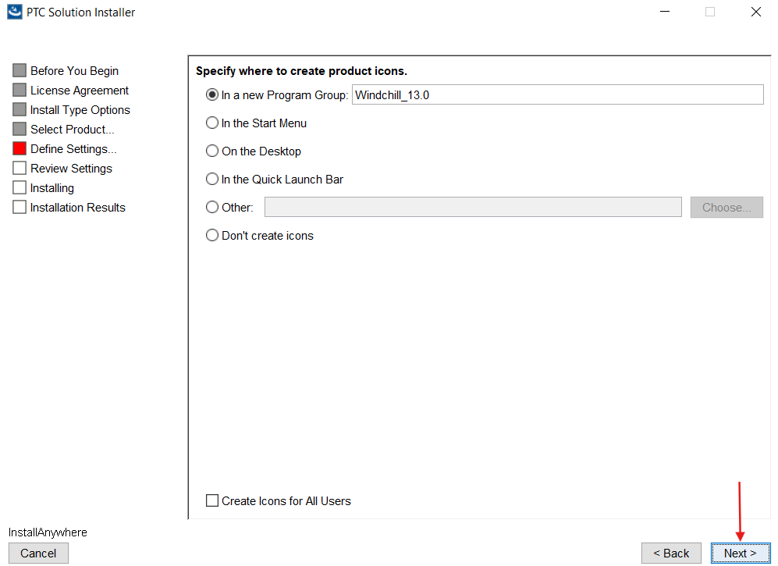

28. Click Next.
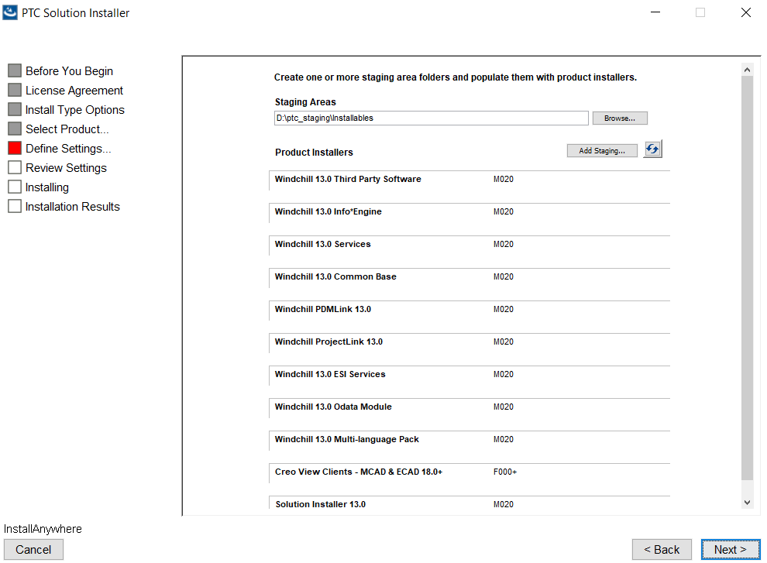

29. Review the details and click on Install as shown below.
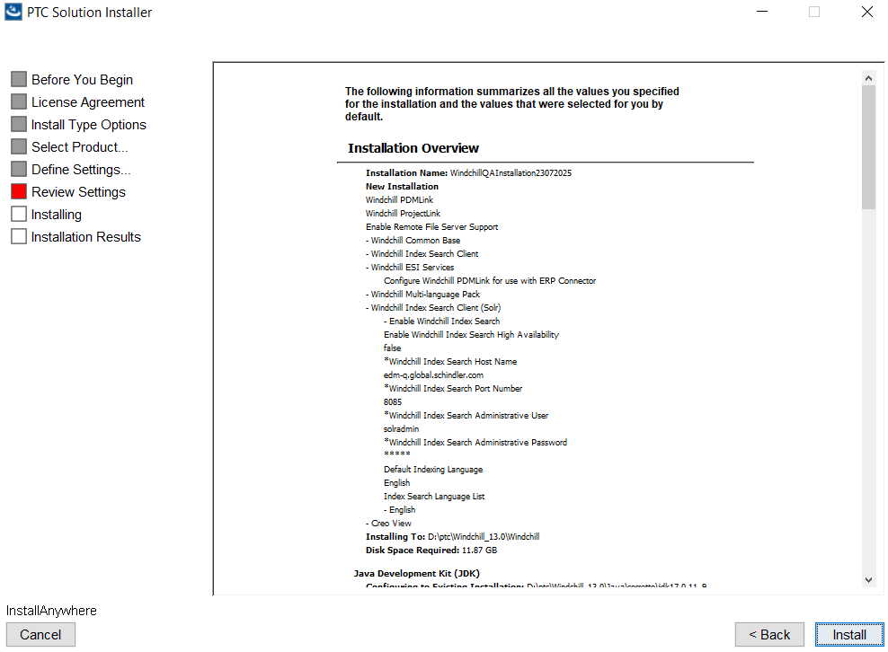
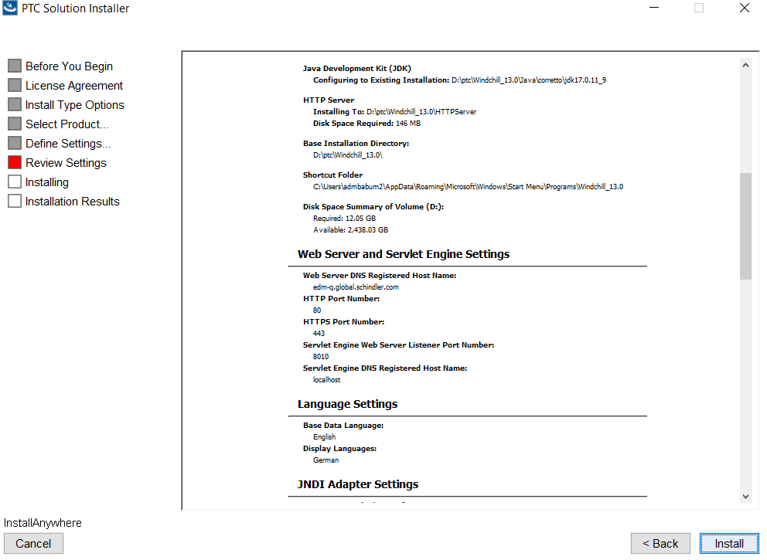
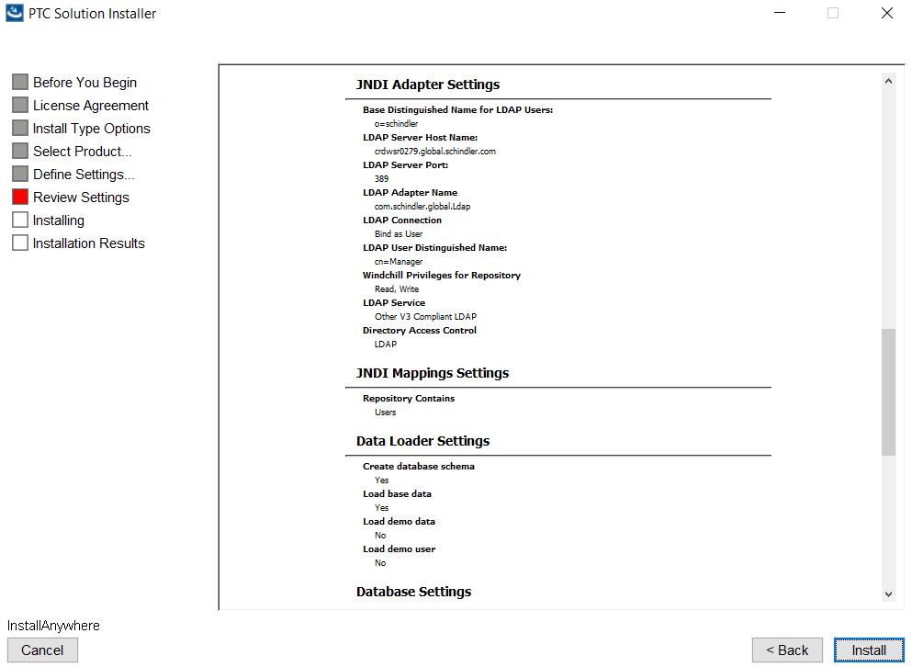
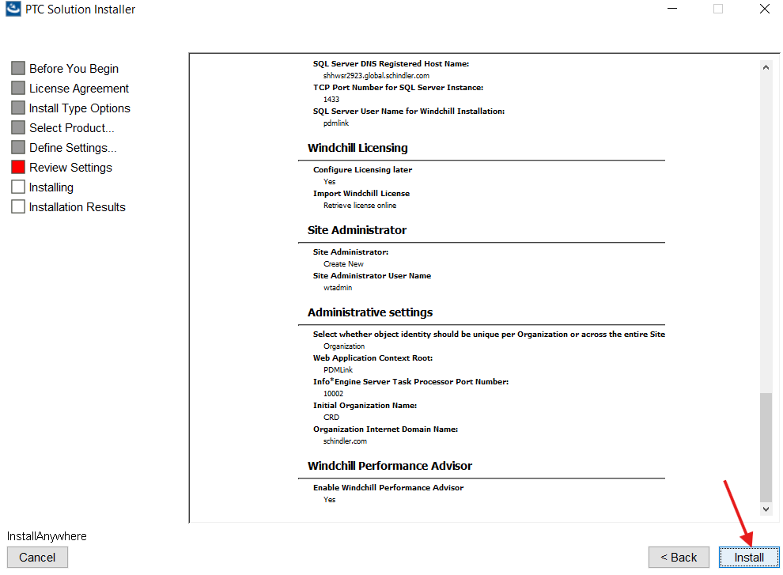

30. Click on Done after the successful installation as shown below.
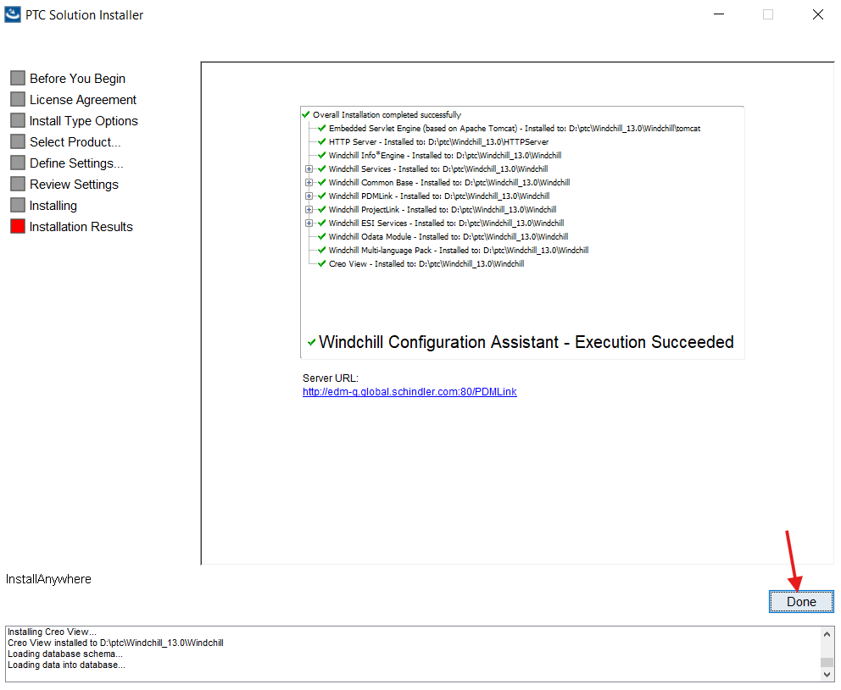

Windchill Launching Issue:
- After successful installation started Windchill and when trying to launch Windchill on web browser the http URL is automatically redirecting to https, and we are unable to launch Windchill.
- Below is the URL we are trying to access.
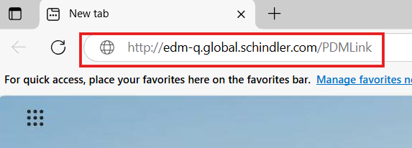

3. After hitting enter the URL is automatically turning into https as shown below.
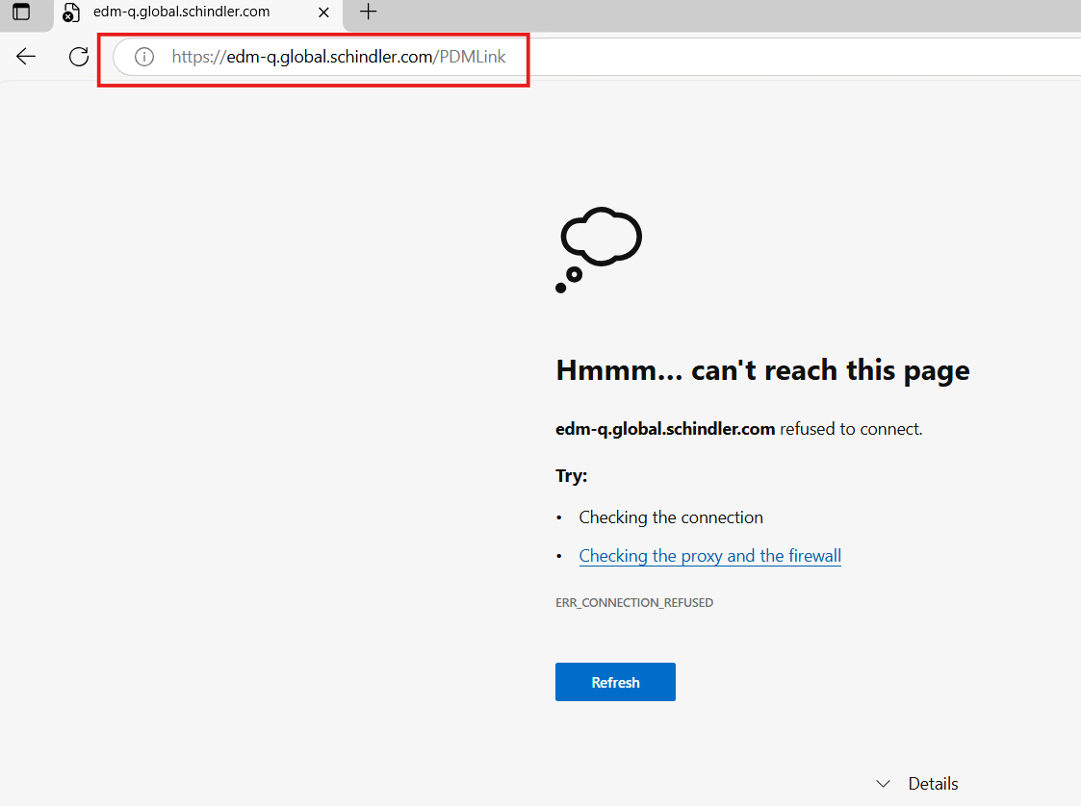

4. Added the below entry in host file, restarted the server to see if it works or not but it did not worked.
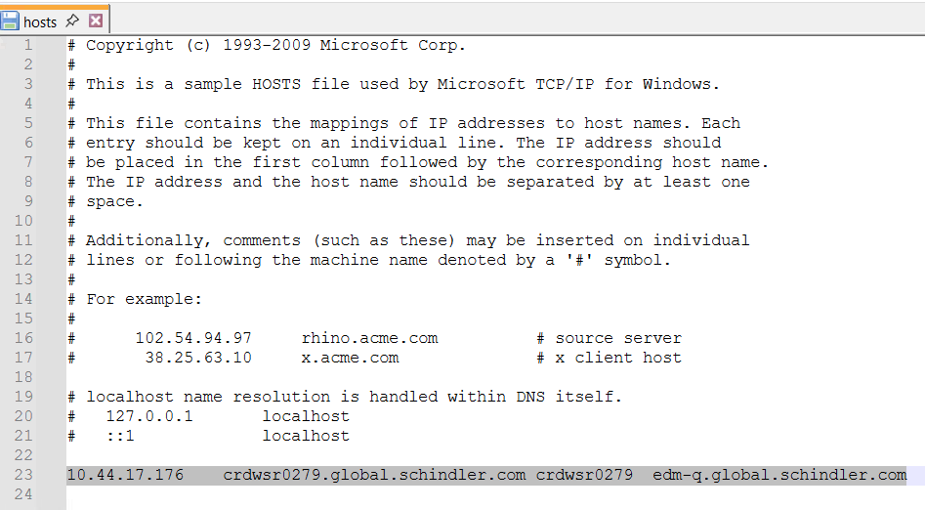
5. To move forward we planned to perform SSL configuration on OOTB Windchill to launch Windchill and see if it is working or not. Later we will disable SSL before running upgrade manager.
6. Please follow the below document for SSL Configuration.
URL: SSL/HTTPS Configuration-Rh2 - Schindler CRD Applications - CRD Confluence
7. After SSL Configuration the issue is resolved, and we were able to launch Windchill.

